School Meals and Nursery Fee:
Notice of Pricing Changes from September 2023
Dear Families,
We are all suffering the increase cost of living and are seeing our own household bills increasing. This is also true in school. We are seeing significant increases in food costs, energy costs and staff costs which is in danger of impacting on the quality of education that we can provide the children.
We have held off as long as possible, but we are now in a place where we will need to review the prices of school meals and nursery fees. Nursery fees have remained mainly unchanged for a significant amount of time, and we can no longer cover the costs within the current pricing structure.
To give some context and evidence to support these revised costs I have shared some of the increases we have had to absorb:
- Food costs – we have suffered a 37% increase in costs.
- Staffing costs – £399K increase in teacher pay and £682K increase in support staff.
- Energy costs – there has been a £92K annual increase in utilities.
In no way are we attempting to profiteer from the revised pricing, they are to ensure that we cover costs and can provide nutritious healthy meals and excellent staffing and resources for our youngest children.
School Meals Pricing
From 1st September 2023 all school meals will cost £2.50 (£1.50 for nursery children) unless you are eligible for Free School Meals. If you are unsure if you qualify for Free School Meals, contact the school office, they will be able to help.
From the 1st January 2024 school meals will be priced at £2.60 per meal (£1.60 for nursery children).
Nursery Fees Hourly Pricing
From the 1st of April 2024 nursery fees for 2-year-olds will remain at £5.30 per hour and nursery fees for 3- and 4-year-olds will be £4.50 per hour.
We understand that in the current climate any revised pricing will have an impact and I hope that you can see we have made minimum changes which are to reflect the increased costs that we can no longer sustain.
I hope that you find the extended notice period of some help and I thank you for your understanding and recognition that this has been unavoidable if we wish to continue to provide the very best for your child.
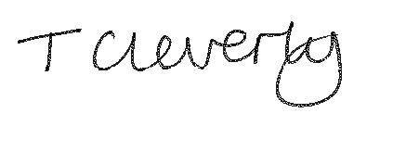
Yours sincerely,
Tracey Cleverly
Trust Lead (Chief Executive Officer)
For and on behalf of the Learning Academy Partnership (South West)

